

24ADC001- BUSINESS INTELLIGENCE

--------------------------------------------------

2026-2027
LAB RECORD

DEPARTMENT OF ARTIFICIAL INTELLIGENCE AND DATA SCIENCE

INDEX
Expt. No | Title of the Experiment | Page No | Total Marks | Faculty Signature
1. | Explore the interface and basic features of the BI tool
2. | Load and visualize a sample dataset.
3. | Import a dataset into the BI tool. And Cleanse data by handling missing values, outliers, and  inconsistencies.
4. | Transform data to suit BI reporting requirements and Design a dashboard with  key performance indicators (KPIs).
5. | Develop interactive dashboards for dynamic data exploration.
6. | Integrate data from various sources for comprehensive analysis
7. | Implement advanced chart types (treemaps, heatmaps, etc.).
8. | Apply BI tools for forecasting and predictive analytics.

Average marks Faculty Signature

EXPT NO:1 | EXPLORE THE INTERFACE AND BASIC FEATURES OF BI Tool
DATE: 10.07.2026

Github - https://github.com/j-abhishek26/24ADC001-24BAD002/tree/main/Experiment%201

PRE-LAB QUESTIONS (PROVIDE BRIEF ANSWERS TO THE FOLLOWING QUESTIONS)

- What is the purpose of Business Intelligence (BI) tools like Tableau and Power BI?
BI tools let users connect to varied data sources, clean and transform raw data, and build interactive visual reports and dashboards so that trends, patterns, and outliers can be spotted quickly. This supports faster, evidence-based business decisions without needing to write complex queries every time a new question comes up.
- List any three common data sources that Tableau and Power BI can connect to.

(1) Flat files such as Excel and CSV files, (2) relational databases such as SQL Server, MySQL, or PostgreSQL, and (3) cloud/web services such as Google Analytics, Salesforce, or Azure SQL Database.
- What is a dashboard in BI, and how is it different from a single chart?

A dashboard is a single canvas that combines multiple charts, tables, and KPIs, often linked so that filtering or clicking on one visual updates the others. A single chart shows only one view of one metric, while a dashboard presents several related metrics side by side, giving a fuller, more actionable picture of performance.

- Define the following terms:

(a) Visualization: The graphical representation of data (charts, graphs, maps) used to reveal patterns, trends, and outliers more intuitively than raw numbers. (b) KPI: A Key Performance Indicator - a quantifiable metric tied to a specific business goal, used to track performance against a target (e.g., average prediction error). (c) Data Filter: A control that restricts the data shown in a view to records meeting specified criteria, without altering the underlying dataset.

- Why is it important to clean and transform data before visualization?
Raw data often contains missing values, duplicates, incorrect data types, or inconsistent formatting. Visualizing such data as-is can produce misleading charts, broken aggregations, or incorrect conclusions, so cleaning and transforming it first ensures that the resulting insights are accurate and trustworthy.

- What kind of chart would you use to analyze stock price trends over time?
A line chart, with the date on the X-axis and price on the Y-axis, since it best represents the continuous change of a value over time and makes upward/downward trends easy to spot.

- Explain the role of slicers in Power BI and filters in Tableau.

Both let the end user interactively narrow down the data shown in a view - for example, isolating one stock or a specific date range - across one or several linked visuals at once. Power BI's slicers appear as always-visible, clickable controls placed directly on the report canvas, while Tableau's filters can be applied to a single sheet or pushed to every sheet in a dashboard, and optionally exposed as an interactive filter card.

- What does a calculated field or measure do in BI tools?

It creates a new field derived from a formula applied to existing columns (for example, Prediction Error = ABS(Predicted - Close)). It does not exist in the source data but is computed on the fly and can then be used in any visual exactly like a normal field.

- What are the advantages of using interactive dashboards for financial data analysis?
They allow real-time drill-down into a specific stock or period, side-by-side comparison of predicted versus actual values, quick spotting of anomalies or outliers, faster decision-making, and let different stakeholders explore the same underlying data without needing a brand-new static report each time.

- Which function would you use to find the absolute difference between predicted and actual stock prices?

The ABS() function - e.g. in Tableau: ABS([Predicted Price] - [Close]); in Power BI DAX: ABS('Table'[Predicted Price] - 'Table'[Close]).

IN-LAB EXERCISE:
Objective:
To understand the basic interface, data import process, and fundamental visualization capabilities of Tableau and Power BI using a stock prediction dataset, and to explore their usefulness in analyzing financial data.

Tools Required:
- Tableau Public / Tableau Desktop
- Power BI Desktop
- Sample Dataset (CSV/Excel) containing:
Date, Stock Name, Open, Close, High, Low, Volume, Predicted Price

Exercise Steps:
Part 1: Working with Tableau
- Launch Tableau and connect to the stock prediction dataset.

Explore the Interface:
  - Understand components like Data Pane, Sheets, Marks Card, and Dashboards.

Create Basic Visualizations:
  - Line Chart: Show Close Price over time.
  - Scatter Plot: Plot Volume vs. Predicted Price.
  - Highlight Table: Display Predicted Price by stock.
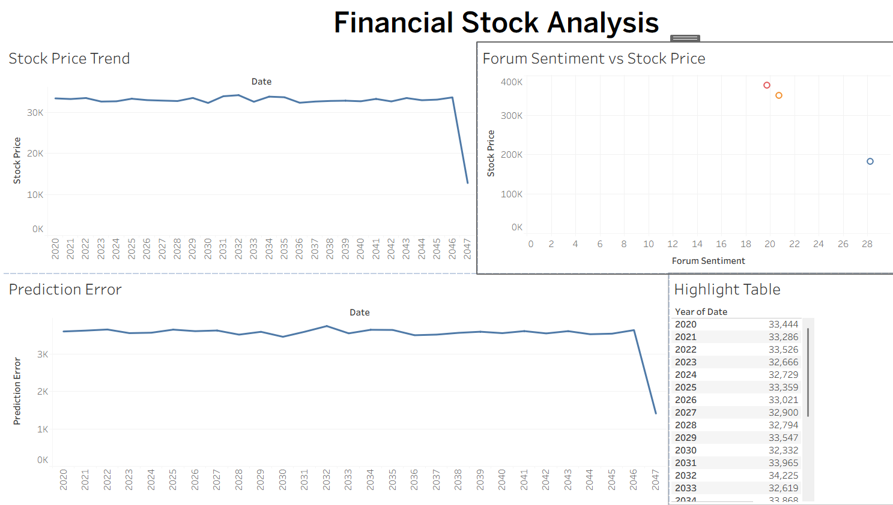

Apply Filters:
  - Add filters for Stock Name and Date Range.
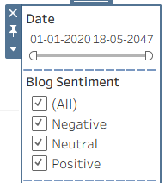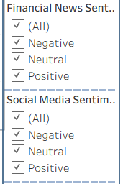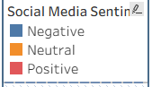

Create Calculated Field:
  - Calculate prediction error as |Predicted - Close|.

Design a Basic Dashboard:
  - Combine your charts into one interactive dashboard.
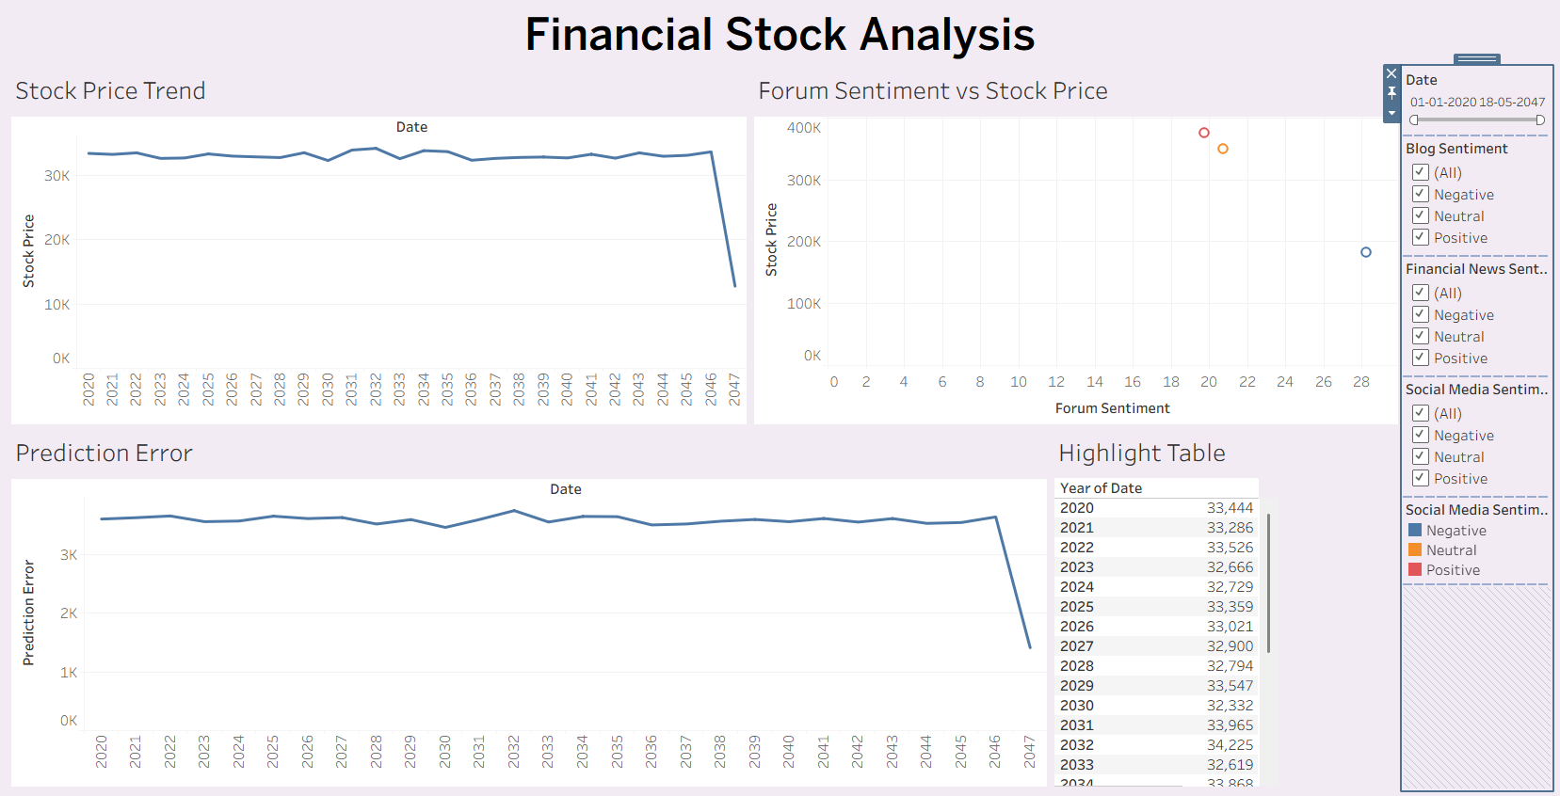

Part 2: Working with Power BI
- Open Power BI Desktop and import the same dataset.

Explore the Interface:
  - Familiarize with Fields Pane, Visualizations Pane, Report View, Data View.

Create Basic Visualizations:
  - Line Chart: Trend of Close Price over time.
  - Bar Chart: Compare Predicted Price vs. Close Price.
  - Card (KPI): Display average prediction error.
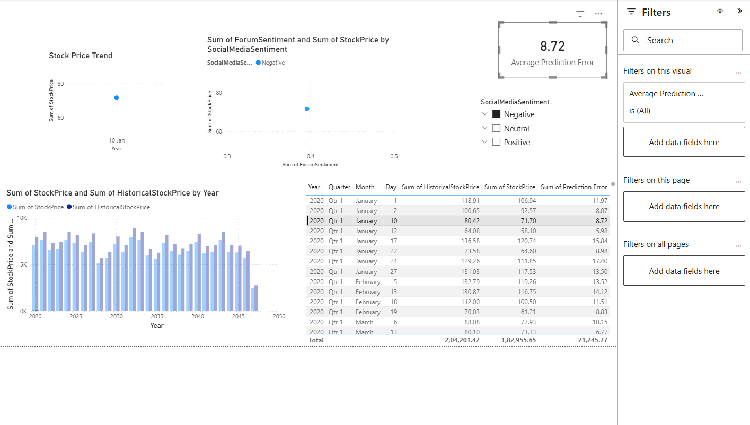

Use Filters and Slicers:
  - Filter data based on Stock Name and Date.
- Create a Simple Measure using DAX:
  - Example: Prediction Error = ABS(Predicted - Close)

Build a Report Page:
  - Arrange visuals in a single interactive page.

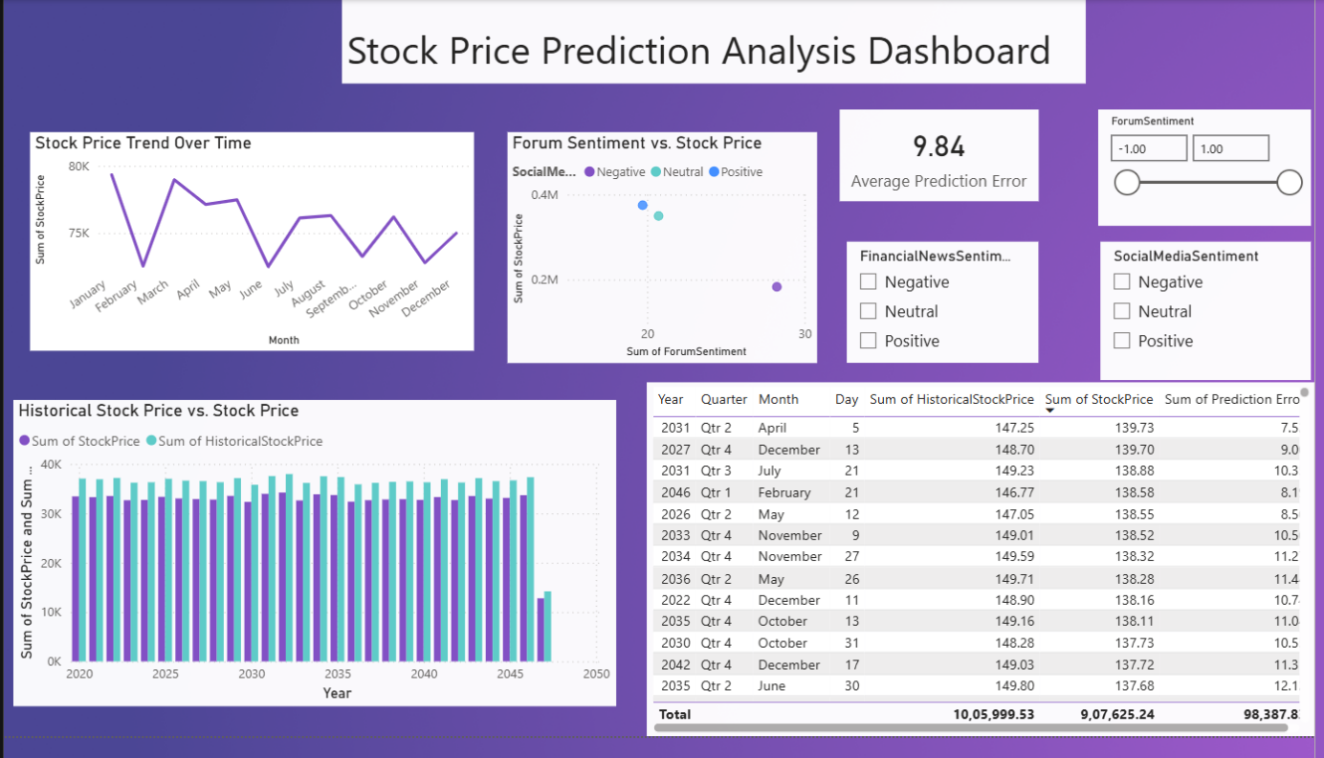

POST-LAB QUESTIONS (PROVIDE BRIEF ANSWERS TO THE FOLLOWING QUESTIONS)
- Describe your experience with the Tableau interface. What components did you interact with?
The Tableau interface was simple and user-friendly. I interacted with the Data Pane, Columns Shelf, Rows Shelf, Marks Card, Filters, Worksheets, and Dashboard. These components helped me create charts, apply filters, and design an interactive dashboard for stock data analysis.
- How did you import the dataset into Tableau and Power BI?
Tableau:
- Opened Tableau Public/Desktop.
- Clicked Connect → Microsoft Excel/Text File.
- Selected the dataset and loaded it.
- Verified the data types and opened a worksheet.
Power BI:
- Opened Power BI Desktop.
- Clicked Home → Get Data → Excel/CSV.
- Selected the dataset.
- Clicked Load to import the data into the report.
- What types of visualizations did you create in both tools? List at least two per tool.
Tableau:
- Line Chart (Stock Price over Time)
- Scatter Plot (Forum Sentiment vs. Stock Price)
- Highlight Table
- Prediction Error Line Chart
Power BI:
- Line Chart (Stock Price Trend)
- Clustered Column/Bar Chart (Historical Stock Price vs. Stock Price)
- Scatter Plot
- Card (Average Prediction Error)

- How did you calculate the prediction error, and how was it displayed in your dashboard?
The prediction error was calculated using the formula:
Prediction Error = ABS (StockPrice − HistoricalStockPrice)
In Tableau, it was created as a Calculated Field and displayed as a line chart.
In Power BI, it was created using a DAX calculated column and the average prediction error was displayed using a Card visual.

- Which filtering or slicing techniques did you apply, and what insights did they reveal?
I applied filters and slicers for Date, SocialMediaSentiment, FinancialNewsSentiment, and BlogSentiment. These filters helped analyze stock price changes under different sentiment conditions and allowed comparison of prediction accuracy across different dates.

- Compare the process of creating a line chart in Tableau vs. Power BI. What differences did you notice?
In Tableau, I created the line chart by dragging Date to the Columns shelf and StockPrice to the Rows shelf. Tableau automatically generated the chart.
In Power BI, I first selected the Line Chart visual and then assigned Date to the X-axis and StockPrice to the Y-axis.
Overall, Tableau follows a worksheet-based drag-and-drop approach, while Power BI uses the Visualizations pane to configure charts.
- How did you organize the dashboard in Tableau and Power BI? What key elements did you include?
I arranged all visualizations on a single dashboard/report page for easy analysis. The dashboard included:
- Line Chart
- Scatter Plot/Bar Chart
- Prediction Error Chart/Card
- Filters/Slicers for Date and Sentiment fields
This layout made the dashboard interactive and easy to understand.

- Which tool (Tableau or Power BI) did you find more user-friendly for financial data visualization, and why?
I found Power BI more user-friendly because it offers simple drag-and-drop visualizations, easy DAX calculations, and smooth integration with Excel. Tableau, however, provides more flexibility and advanced customization for creating interactive and visually appealing dashboards.

- What challenges did you face while creating visualizations or dashboards?
Some challenges included selecting the appropriate chart type, creating the prediction error calculation, configuring filters and slicers, formatting the dashboard, and arranging the visualizations properly. Understanding the different interfaces of Tableau and Power BI also required some practice.

- How can the knowledge gained from this lab be applied to real-world financial data analysis?
The knowledge gained from this lab can be applied to analyzing stock market trends, comparing predicted and historical stock prices, evaluating prediction accuracy, identifying market patterns, and creating interactive dashboards for financial reporting. These skills are useful for business intelligence, investment analysis, and data-driven decision-making.

ASSESSMENT

Description | Max Marks | Marks  Awarded
Pre Lab Exercise | 5
In Lab Exercise | 10
Post Lab Exercise | 5
Viva | 10
Total | 30
Faculty Signature

